Practical 6 - Kivy

Note: This is a fairly long practical. You should get started early (before the prac session) and you will probably need to put in more time after the practical session. You do not need to fully understand the classes and methods used in Kivy. We will fill in some of those details as we keep learning more in the subject. There are a lot of demos to learn and copy from.

If you’re using your own computer, you can find instructions for installing Kivy at: <https://github.com/CP1404/Starter/wiki/Software-Setup>

# Walkthrough Example - Kivy

**Download a zip** of the GitHub repository for our Kivy Examples: https://github.com/CP1404/KivyDemos

You could use Git to **clone** it, which makes a complete copy, including the Git history, but since you don't have write permissions on this repo you will not be able to push changes back to it. The easiest thing is just to use the GitHub website to "Download Zip".

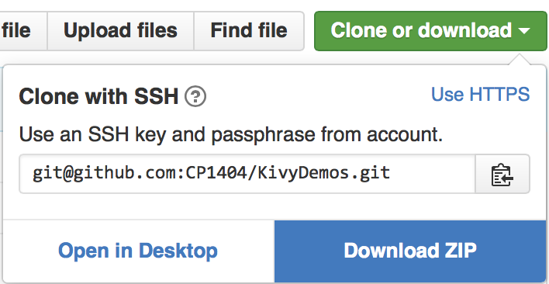

1. The work that you do today should be saved, committed and pushed to your Practicals repository in the Prac06 folder. The simplest thing is to just **copy everything from the zip you just downloaded into your Practicals/Prac06 folder**. Then only commit the work you do today (you don't need to upload all of the other examples to GitHub).
2. (Here's a simple example) Open and run the **hello_world.py** file.  
   You should see a lovely black window with “HelloWorld” in the title.
3. (Here's an advanced example) Open and run the **popup_demo.py** file (which uses **popup_demo.kv**) and run that to see how it works. You don't need to understand it all just yet, but try to get an overview of the structure and look for the parts you do recognise.

### Screen Shot 2015-10-06 at 12.45.13 pm.pngModify Existing GUI Program

Open the **box_layout_demo.py** and **box_layout.kv** files and run the Python program. You should see three vertical buttons.

Let’s extend this program to make an app that lets the user enter and clear their name, and greets them when we push a button. It will end up looking like this:

1. Add a **label** below the third button with the **text** “Enter your name”:

**Button**:

**text**: **'three'**

**Label**:

**text**: **'Enter your name'**

1. Set the new label’s text colour to yellow, by adding the following property details “inside” the label:

**color**: (1, 1, 0, 1)

1. Update the first button so it says “Clear” and the third button so it says “Greet”.
2. Now to add a button handler, you need to edit both the py and kv files. Look at the ‘id_demo’ files for a good example of this…  
   Add a callback for the press event in the kv file, like:

**Button**:

**text**: **'Greet'**

**on_press**: **app**.handle_greet()

This references a method in your main app class called **handle_greet()**.

1. Add this function in your .py file and simple put a print('greet') statement in that function.  
   Test it.   
   If this works and you see ‘greet’ in the console (not the Kivy window), then you know the connection between the button and this function works, so you can extend it.
2. The next step is to change the text of the label.  
   Add an id to the label, like:

**id**: output_label

1. Now in your handle_greet function, change this label’s text, like:

**print**(**"test"**)

self.root.ids.output_label.text = **"Hello "**

1. Change button “two” to a text input field, like:

**TextInput**:

**id**: input_name

**text**: **''**

1. Since it’s got an id, we can now use the information in this text entry field in our button handler, like:

**… "Hello "** + self.root.ids.input_name.text

You should now be able to type in the text field and click the button to greet by name.  
Test it and update as needed.

1. Lastly, add a new event handler for the clear button so that it resets both the text field and the output label to blank.

# Intermediate Exercises

Open the **squaring.py/kv** files from KivyDemos.

Run the code to see a simple app with a text entry field, a button and a label that squares a number.   
Spend a while reading the code so you know how it works. Pay special attention to the functionality – how it handles the button being pressed:

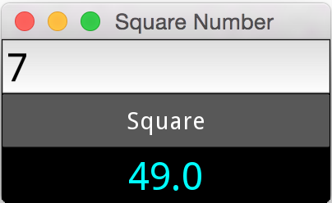

## Make the following modifications:

* Change the output text colour to pink (**color** is an RGBA tuple).
* Change the orientation so the widgets display left-to-right instead of top-to-bottom.
* Add a label at the bottom with the text, Enter a number and press "Square".

So you will need to use nested layouts for this. There are two 'sections' (BoxLayout) arranged vertically.

* In the top section, there are three widgets, organised with a BoxLayout, arranged horizontally.
* In the bottom section, there is just one label.

**Refactoring Example:**

Have a look at this commit "diff" for the squaring program: <https://github.com/CP1404/Practicals2016/commit/2f9b38dcfc393e2f50f9b30f6da36f9aabf4ee1f>

You can see that we changed the code so the button handler function now takes in the value of the text field as a parameter instead of getting it. This makes the logic less tightly coupled to the view. It still puts the calculated result back in the view directly, so it's only one step towards better separation, but it does show you how Git and GitHub can record and show your progress as you improve your code by refactoring it.

# From Scratch

Create a Kivy program and use the kv language to recreate the following layout.  
(The dark grey with white boxes are buttons, the black with yellow is a label and the black on white one is a text input.)

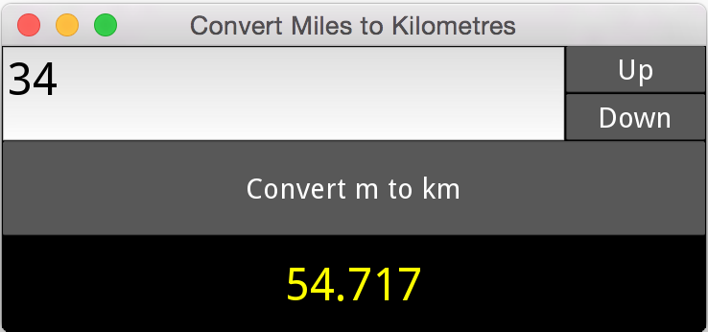

When you have created the layout, write the functionality for the whole program.

* You should be able to type a number in the text entry field
* Pressing Up/Down should make this number go up/down by 1
  + Note: You can handle both of these with the same function by passing a value, e.g.  
    **on_press: handle_increment(-1)**
* Pressing the “Convert” button should calculate the conversion from miles to kilometres and display this in the bottom label. (Oops, “m” in the screenshot is not a good abbreviation for “miles”.)

Stage 2:

* Handle invalid inputs. If the text entered is not a valid number, just display 0.0 as the output.   
  It should not crash or produce errors in the console.
* Pressing Up/Down when the box is empty or invalid should assume the value is 0 and change it to 1/-1.
* Remove the convert button and make the result appear immediately when either text is entered or the up/down buttons are pressed

**Note:** The solution to this is provided in your Kivy Demos repository.

Don’t just copy it, but do use it if you get stuck, and/or to compare your solution to ours.

## Dynamic Kivy Widgets

All of these programs so far have had the widgets "hard-coded" in the .kv file, but what if we want to create dynamic widgets based on a variable or the contents of a file or something?

Open **dynamic_widgets.py/kv** to see how this can be done.

The keys to this are:

* Give the layout widget that you want to add items to an id (in the .kv file)
* Create the widgets (e.g. buttons) in Python code, e.g. temp_button = Button(text=name)
* Add these new widgets using the **add_widget** method, e.g. self.root.ids.entriesBox.add_widget(temp_button)
* To add event handler code, bind a function callback when you make the widget object, e.g. temp_button.bind(on_release=self.press_entry)

So now it's your turn...

Create a very simple app that loops through a list of strings and displays each one as a separate label.

## Customising Kivy Widgets

Open, run and inspect Jason’s QuickSum Kivy app from (two files, **quick_sum\*** .py and .kv).

As explained in the lectures, notice the way it uses:

* class rules like <Button>
* canvas.before and canvas.after to change the background colour or other aspects of a widget

Use these techniques to change your miles->kilometres converter to use black text on white background widgets - or something else that you’d like visually.

# Practice & Extension Work

1. Modify your Greeter Program so the GUI layout looks like:

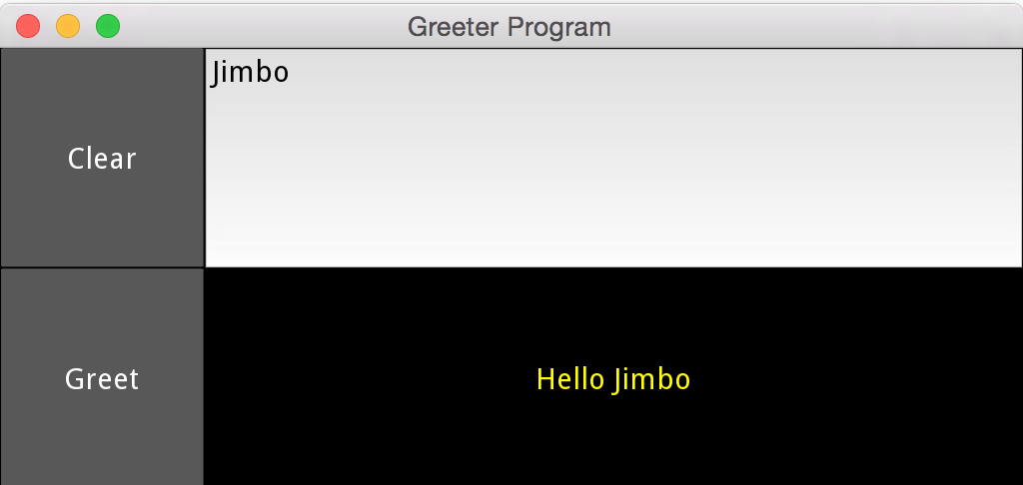  
Hint: BoxLayouts inside a BoxLayout, and a size_hint_x...

1. Create a simple GUI similar to your greeting app that lets a user type in their score out of 100, click a button and the app shows "Pass" or "Fail" (based on the value) in a label.
   1. Then extend this to show the JCU grade (e.g. 65-75 is a credit).
2. Make a GUI for the temperature converter program you did in the first practical.   
   It will be very similar to the miles to kilometres program, but instead of just copying that one and modifying it, try doing the new one from scratch and only looking at the miles converter to help you if you need it.
3. Make a dynamically generated GUI with a button for each person found in a file. Load the file at the start, that contains lines like "Name,age" (e.g. "Bill Gates,72"). Display one button for each person with their name on the button. When you push the button it should show their age in a label at the bottom.
4. Do you have an **Android** device? If so, run one or more of your Kivy apps on it using Kivy Launcher, as described at: <http://kivy.org/docs/guide/packaging-android.html#packaging-your-application-for-the-kivy-launcher>

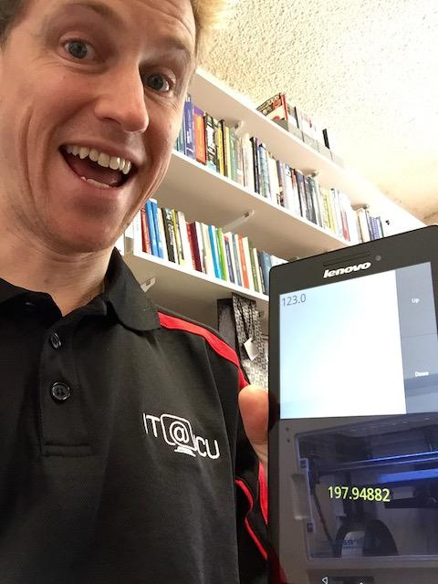If your Android device does not have an SD Card installed, then place your Kivy apps within internal storage, in a folder called kivy, with a subfolder for your project, and make sure you have a **main.py** and **android.txt** (as explained at the link above) in that folder, like this:

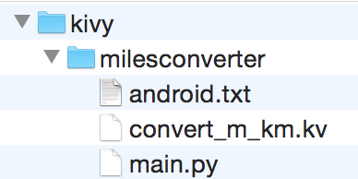

Then you’ll experience much joy with your (first!) Android app, like this ->

You may also want to look at **python-for-android:** <https://github.com/kivy/python-for-android>

## Implement our “GuessingGame” app

We started working on a simple guessing game Kivy app here: <https://github.com/CP1404/GuessingGame>

* Form a team of two students for some **pair programming**
* Have a look at the repo, and try your hand at making the app work
* Then make a Pull Request back to us.
* We will merge in the best Pull Requests!